Editors - Node Editor
Node Editor 1
Node Tree Types 2
Regions of the Node Editor 2
Toolshelf 2
Properties Region 3
Header 3
Editor 3
Activating Nodes 3
Node Editor Window Actions 3
Node Editor Header 3
Node Parts 4
Title 5
Sockets 5
Inputs 6
Outputs 6
Preview 6
Settings 7
Using Nodes 7
Adding Nodes 7
Arranging Nodes 7
Auto-offset 7
Connecting nodes 8
Disconnecting nodes 8
Duplicating a node 8
Node Groups 9
Grouping Nodes 9
Editing Node Groups 10
Ungrouping Nodes 10
Appending Node Groups 10

Node Editor by Tools

Regions of the Node Editor

Toolshelf
The toolshelf *

Properties Region
The properties region *

Header
The header contains the View, Select, Add and Node tools.

Header

View
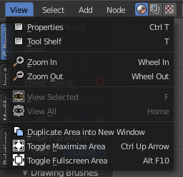

Select
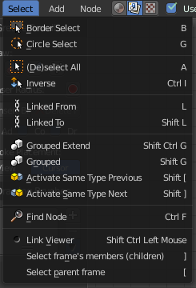

Add
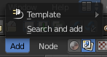

Node
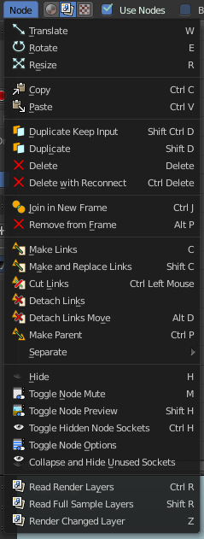

Header 1 nested in a table

Note
Text body in Bold
Text Body
List Heading
List contents

